Curriculum Vitae
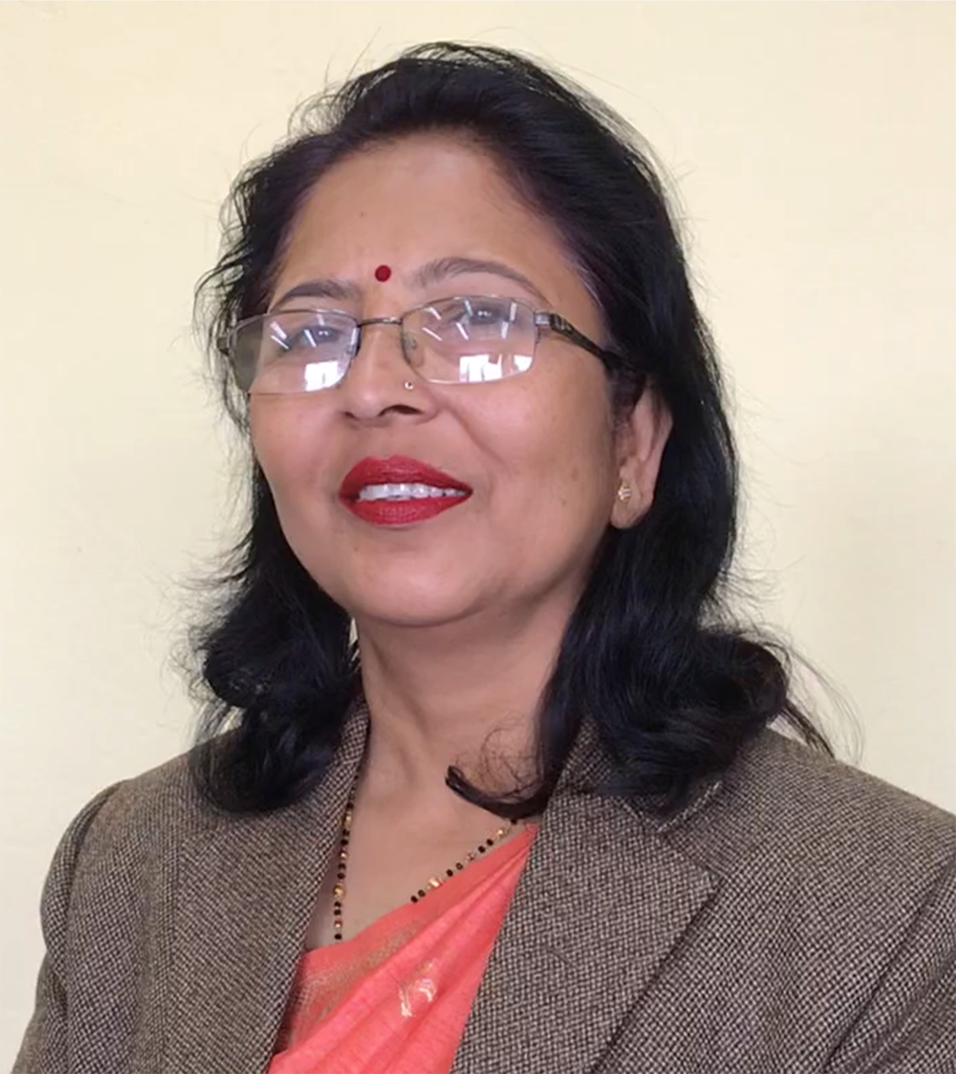

Ms. Kamala Parajuli
Hon'ble Chairperson of National Women Commission
PERSONAL DETAILS
Birth Place : Morang District (Eastern Terai)
Marital Status: Married, two children
Nationality : Nepali
Address : Koteshwor-35, Kathmandu, Nepal
Contact No : 9851313093
Email : kamala.parajuli@nwc.gov.np

ACADEMIC QUALIFICATIONS

PHD in Buddhism and Gender –Running
Master's Degree in Nepali - TU, Nepal in 1999
Bachelor's Degree in Humanities – TU, Nepal in 1992

MAJOR RESPONSIBILITIES
- Hon' ble Chairperson of National Women Commission (February 3, 2021)
National Women Commission is constitutional body responsible for the protection and promotion of women which is also responsible for monitoring women rights situation, policy formulation etc.
- Executive President, Sankalpa Nepal (July, 2006 to August,2018)
Sankalpa Nepal is a social organization working for the social security and Human Rights of Senior Citizen from 2006.
- Executive Member, Nepal Peace and Solidarity Council, Nepal chapter
- Vice President, Sancharika Samuha (Women's communicators' Forum), till January 2007.
- Working in the area of Ageing, Women Rights, Child Rights and Human Rights from 1990.
- Editorial Board Member, Nawayug Monthly (May 2003).
- Coordinator at Informal Sector Service Center (INSEC) on women and child program Department (May 1993 to July 2001)
- Freelance Trainer/Writer/Journalist.

TRAININGS
- Participated in 3 days training seminar on “Healthy Ageing Care for the Older People of Nepal” on January 2009 organised by Institute of Medicine(IoM) and CONNECT for CHANGE (CfC).
- Participated in the Training Program on "Understanding Conflicts and Building Peace by Systematic Conflict Transformation" from 1 -6 Feb. 2007 organized by FES Nepal.
- Participated in the Training Program on "Conflict Transformation and Reconciliation Training For Peace Communicators", 19 -25 Aug. 2006, Organized by FES Nepal.
- Participated in the Training Program on "Conflict Transformation Training For Peace Communicators", 21 -25 Feb. 2006, Organized by FES Nepal.
- Participated in the Training Programme on "SOCIAL WORK", From 28 Nov-6 Dec 2005, Organized by UNICEF and College of social work and community development university of Philippines.
- Participated in the Training of Trainers (TOT) on Optional protocol of CEDAW, organized by FWLD from 9th to 11 April 2005.
- Participated in the Conflict Transformation Workshop on New Delhi from 1 June to 9 June, 2003 Organized by Women In Security, Conflict Management and Peace (WISCOMP) .
- Participated in the Training of Trainers (TOT) on Conflict Transformation by Peaceful Means from 10-12 December, 2002 and 16-17 April organized by National Human Rights Commission and German Technical Cooperation.
- 11th Annual Human Rights and Peoples Diplomacy Training 26 Feb. – 16 March 2001, Bangkok, Organized by the University of New South Wales, Australia.
- A 13 day Training on design, Management and Evaluation of Development Project 30 April –12 May 2000, Kathmandu, Organized by Agricultural Projects Services Center (APROSC) and ILO.
- Women Health Training 15-30 August 1997, organized by WOREC, Nepal.
- A (10 days) Course on Participatory Techniques to Prevent Commercial Sexual Exploitation of Children, 1-10 April 1997, the Philippines.
- Training on Management Development for NGOs, 24 June – 2 July 1996 Organized by Socio-legal aid Research and Training Center, Calcutta, India.
- Gender Equality Training, Organized by OXFAM Nepal, June-1993.

WORK EXPERIENCES

- Consultant on "Finalization of Comprehensive Minimum Standards for the Care of Children in Nepal" from 1st April to 30th August, organized by UNICEF Nepal and Central Child Welfare Board.
- Resource person on the "Feature Writing Training" for women Journalist, 21-27 December 2006, Nagarkot, Organized by Sancharika Samuha.
- Consultant on the "Mid Term Review of Child Protection and Development Program" from 1st Oct to Dec 15, 2006 Organized by Save The Children Norway.

- Resource Person in the Training Programme on "Appreciative Management and Self Development Training", From 24-26 Sept. 2006, Organized by Kathmandu Metropolitan City and Sankalpa Nepal in Nagarkot, Kathmandu. The Training was organized for the staff members of Kathmandu Metropolitan city.
- Resource Person in the Training Programme on "Conflict Transformation Training For Peace Communicators", From 7-10 July. 2006, Organized by FES Nepal in Chitwan. The Training was organized for leaders of different political parties.
- A Documentation of work of para-legal committees in seven districts (Sunsari, Udayapur, Parsa, Chitwan, Kapilvastu, Dang and Tanahu) as a Lead Researcher conducted by UNICEF, Nepal For five month period between September 2005 to January 2006.
- Resource Person For Confidence Building training For Conflict Victim Women at Kailali, on 25-28 Sept., 2005 Organized by MGEP and WDO Kailali branch office.
- Resource Person for Confidence Building training to Women Conflict Survivors at Bardiya, on 20-26 August, 2005 Organized by MGEP and WDO Bardiya Branch Office.
- Developed Training Guideline About Confidence Building Training For Conflict Victim Women For MGEP, July 2005.
- Resource person for Gender Equity and Appreciative Leadership Training For NGO Leaders in Nepalgunj, 1st to 7th June 2005 Organized by NGO Federation .
- Coordinator / Trainer for the Feature Writing Training for Women Journalists, Kathmandu, Feb 22 to 28th 2005, organized by Sancharika Samuha.
- Resource person for SWOT analysis and project facilitation for Lutheran World Federations partner organization Morang, December 19-22, 2004, organized by Lutheran World Federation.
- A research on mapping and assessment of residential care facilities for children in Nepal as a deputy team leader conducted by UNICEF, Nepal office November 2003 and March 2004.
- Case study writing on sexual exploitation of women in conflict situation, Banke and Bardiya District (September 2003) conducted by SNV Nepal.
- Coordinator/ Resource Person Facilitation Interaction Programme On " Corruption: A Social Aberration " 7 Dec. 2003, Rauthat District, Organized By National Peace Academy/ ESP.
- Coordinator/ Resource Person Facilitation Interaction Programme On " Corruption: A Social Aberration " 9 Dec. 2003, Parsa District, Organized By National Peace Academy/ ESP.
- Resource Person Facilitation "Senior Citizen's Workshop about Their Problems and solution" On 18-19 June 2003, Udayapur District, Organized by National Peace Academy.
- Resource Person / Consultation for the organization of the Gender in Emergencies Training for the Participatory Disaster Management Program UNDP, on 2-5 December, 2003, Chitwan, Organized by UNDP Nepal.
- Resource Person / Consultation for the organization of the Gender in Emergencies Training for the Oxfam Partners, Oxfam GB/ Nepal, 16-18 Feb.2003, Chitawan, Nepal.
- September 2002 to 14 January 2003 Worked as a Research Associate for the White Paper Project at the National Human Rights Commission, Nepal
- Worked as a member of the jury of the Investigative Journalism Award on the theme "Rights of Girls and responsibility of society" on March, 2002, UNFPA.
- Resource Person for Gender Equity training for rural representatives of Rautahat District organized by Plan International Feb 20 –25 & 26– 30, 2002.
- Resource Person for Gender Equity training for rural representatives of Rautahat District organized by Plan International August 23 –25 & 27– 29, 2001.
- Resource Person / Consultation for the organization of the Gender Sensitization Training for the flood rehabilitation Project for Oxfam GB/ Nepal, 29 July – 1 August 2001, Staff College.
- Gender Perspective Project Evaluation of past flood rehabilitation project, Rautahat District, for OXFAM GB / Nepal, August 2000.
- Coordinator at Informal Sector Service Center (INSEC) on women and child program Department May 1993 to July 2001.

SPECIAL TASKS ACCOMPLISHED
Successfully co-coordinated/organized the following regional/national level programs:
- The First National Conference of Elected Women Representatives, Kathmandu, November 24-26, 1998.
- First National Conference of Women, Kathmandu, 10-12 April 1996
- Forum of Politically Victimized Women in Dhankuta, January 30 – February 1, 1995.
- Regional Conference of Women (Dhangadi, 24-25 Dec.1996/ Pokhara, 8-9 March 1997/ Chitwan, 16-18 Dec. 1997/ Biratnagar, 24-26 Dec. 1997/ Nepalgunj, 21-23 April 1998).
- Regional Interactions on Women's Issues (Nepalgunj, 2 October 1996, Dhangadi, 4 October, 1996, Pokhara, 8 October, 1996, Biratnagar, 29 October 1996, Kathmandu, 17 Dec. 1996).
- Worked as a resource Person for the Role and Responsibility of elected women representatives, a two-day training organized by Children Women in Social Service and Human Rights (CWISH) in the two villages of Nawalparasi 19 -21 June, 1997.
- Coordinator and Researcher of "A study on the impact of Media in the rural sector" Organized by IIDS in September and October 1993 in Dang District.
- Coordinator of "Study in Bhaktapur District making the political profile" on entire existing political parties organized by Himalaya Institute for Development (HID) in April/May 1993.
- A Research conducted on fertility, planning and health status of women in Syangja and Rupandehi District as a team member organized by New Era, IIDS, and Valley Research center (NIV) joint venture in December 1991-February 1992.
- Worked as a supervisor from July 1990 to March 1991, Election Commission Office, Kathmandu
SPECIAL EXPERIENCES

- Conducted Training Programs as a resource person on the issues of Social Security and Human Rights of Senior Citizens, Gender, Human Rights, Child Rights, , Development, Conflict, Appreciative Inquiry, Women Health, Organizational development and leadership training for Local NGOs, Institutions, Political Leaders, Elected women representatives and National level/District level Different Related Stockholders in over 30 districts.
- 2 day Training facilitated on Social Security and Human Rights of Senior Citizen for social activist on regional basis(Itahari, Nepalgunj, pokhara, Kathmandu) organized by Sankalpa Nepal.

- Paper presented and facilitated Workshop on social Security and Human Rights of Senior Citizen on regional basis (Biratnagar, Dhangadi Bharatpur and Kathmandu) organized by Sankalpa Nepal.
- 2 day Training facilitated on Project Cycle Management organized by Sankalpa Nepal on March 2012.
- Chief Editor “ANUKRAM” quarterly Publication and other regular publication of Sankalpa Nepal since last six years.
- Faciliated National old Age Management Training for 7 days on May 2009 organised by National Senior Citizen orgazination Network, Nepal at Babarmahal, Kathmandu.
- A Research conducted as a coordinator on "Marital Status of Nepalese Women" in four Districts i.e. Humla, Rasuwa, Kanchanpur and Saptari for Sherpa, Tamang, Chaudhari and Jha ethnical groups respectively organized by Anti-Slavery International.
- A Research performed as a coordinator on the "Condition of Women in Jails of Nepal" by INSEC in 1996.
- Coordinator at Nationwide Research on the issue of Politically Victimized Women (before Democracy restoration in 1990) as of compile their profile INSEC in July1994 -February 1995.

PATICIPATION OF DIFFERENT NATIONAL AND INTERNATIONAL CONFERENCES

- Third South Asian Free Media Conference on "Media and Democracy" 25-26 May 2003, Dhaka, Bangladesh.
- Second South Asia Free Media Conference On "Media And Peace" on 1-2 January, 2002, Kathmandu, Nepal.
- Workshop on "Law Justice and Human Rights through SWOT" Kathmandu on 30-31 March 1999.
- Workshop on "Media advocacy in relation to women violence", 21-22 May 1998, Kathmandu.
- Fourth World Conference on Women, Beijing, China, 1995.
- South Asian Regional meeting on Ending Violence against Women and Girl in South Asia, Kathmandu, on 21-27 Oct. 1997 (Organized by UNICEF/UNDP).

PAPER PRESENTED
- A paper Presentation on "Appreciative Approach on Gender Issues" On May 2005, Organized by AI Latipur / DDC Latipur.
- A paper entitled" Importance of Women and Elected Representatives in Politics" was presented at the National Conference of Elected Women Representative in Kathmandu on 24-26 November 1998.
- A paper entitled "Human Rights of Women" was presented at the Mini Beijing Conference organized by Beyond Beijing committee in Kathmandu on February 15-18, 1997.

PUBLICATIONS

- Niruttarit Prashnaharu (Unanswered Questions), Story Collection, March-2000.
- Chitizko Badlindo Rang – A novel on social issue -2009
- Preranadayi Byaktitwa (Biography of Senior Communist Political Leaders) - February 2009
- Feminism in Nepal, March-2003
- Shahityakar Sanjaya Thapa (Research Evaluation on literary Figure Sanjaya Thapa), March-2000.
- Nalekhiyeka Katha : Literally means 'the unwritten story' (Story collection)

PAPER EDITED / ARTICLES PUBLISHED
- Publication Edit For Save the Children (US) on September, 2005.
- Publication Edit For IUCN on April-May, 2002.
- Chief Editor - Apekshya Magazine (Three Issue) Feminist Journal, 2001.
- Over Thousands of articles (essays, stories, poems, etc) on and about the Political, social, cultural, Human rights, women rights, child rights and senior citizens' rights: some of them include the following.
- In addition, compiled and edited various reports for 3 issues of Women in Politics, Published by INSEC)

INTEREST
- Research Study on Socio- Economic Situation of Nepalese women, status of Children and Aged Group.
- Participate in the process of social change by the way of newspaper, articles, books, stories, training and so on.

LANGUAGE
- Nepali, English & Hindi
- Bhojpuri and Maitheli

VISITED PLACES ABROAD
- China
- India
- Philippines
- Thailand
- Bangladesh
- United States of America

VISITED PLACES WITHIN THE COUNTRY
More than 60 districts within the country

